Troubleshooting P50 Injektionsarm

Index
Page 1 Problem: Veins leaking
Page 3 Problem: Blood flow not correct

Problem: Veins leaking

The skin and the tubing system of the injection arm are subject to wear and tear caused by usage. We supply the skin or the tubing system as a replacement part.

Overview-This is where you find the veins:
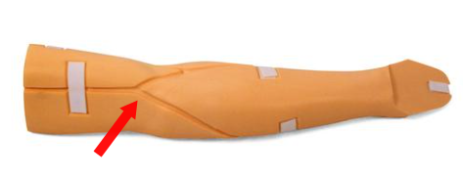

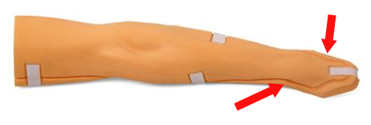
Solution:

1. The vein needs to be replaced

Example of a used up vein -
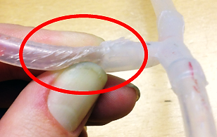

2. The vein receives too much pressure

When using the arm, make sure that the flow control (see picture part 1) and the sealing cap at the end of the short tube (see picture part 2) is closed.
If the flow control (1) is open and the sealing cap (2) is closed there is too much pressure on the veins and they will start leaking.
Especially if the infusion bottle is higher than the delivered stand or substituted by a larger bottle or bag.

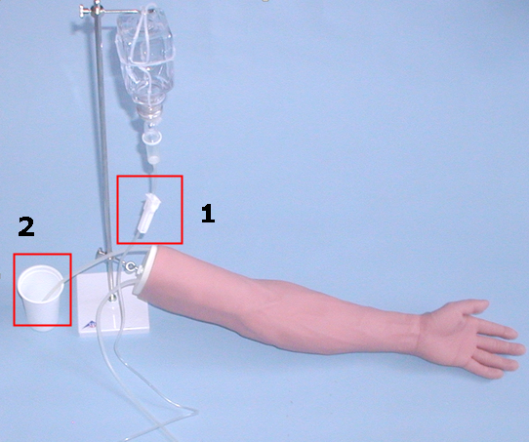

Example- if flow control (1) is open and the sealing cap (2) is closed
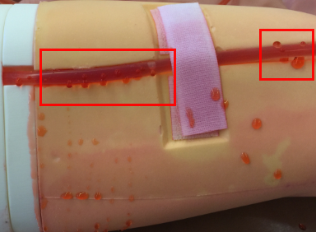

Problem: Blood flow not correct

Solution:

- Connection between drip chamber and infusion bottle. Push the front end of the drip chamber fully into the seal of the infusion bottle.
- Air filter of drip chamber closed, or blocked (happens sometimes if it gets wet)

